If there is no option available in eclipse for window builder or Jframe, then you need to install it within eclipse.
How to check that Swing/Window Builder is already installed in Eclipse?
Follow these steps:
- Click on File menu and select new and then select java project.
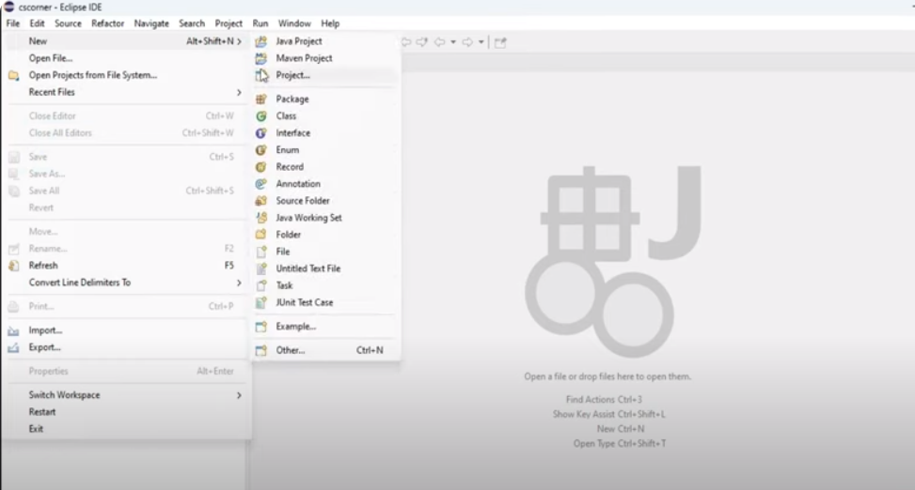

- Add project name and select the option “Use a project specific JRE”
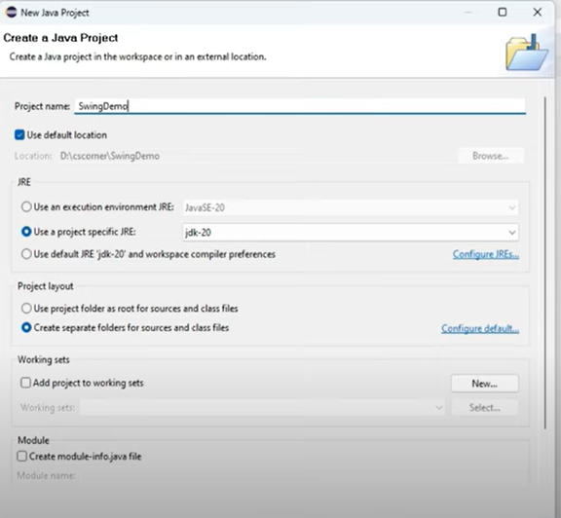
- Click on Next and then finish.
- Project will be created on the left side of the screen.
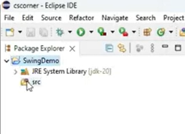
- Right click on src, click on new, and click on Other.
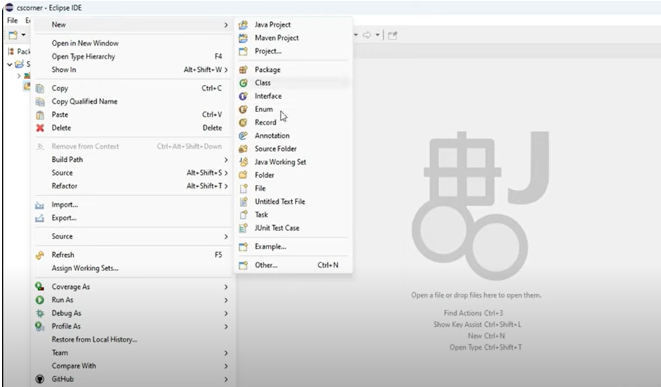
- Type jframe here, nothing will appear.
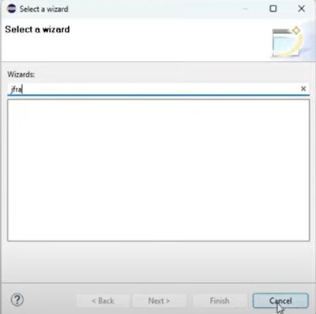
- Which means there is no window builder available, you have to install it by following the given instructions.

How to install Swing/Window Builder in Eclipse
- Go to help option and select eclipse marketplace.
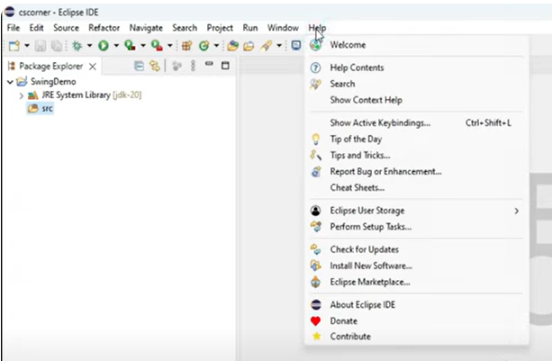
- Type window builder and click on GO button. Now select the first option “window builder current” and install it.
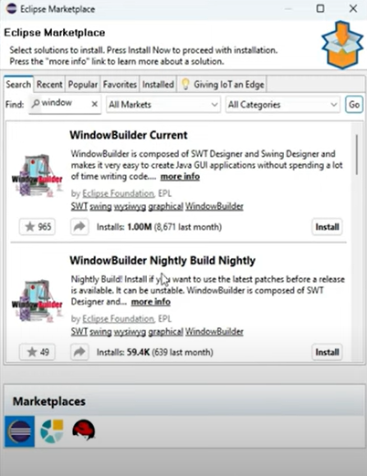
- Agree on the terms and conditions so that installation can be sarted.
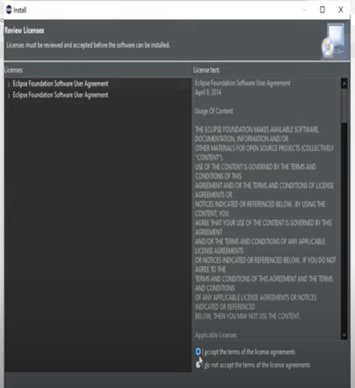
- Once the installation is about to start, it will show you some other options too. Do not uncheck anyone.
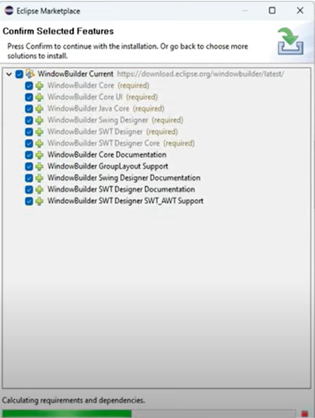
- Once it is complete, just click on finish.
- Now you need to restart your IDE for using it properly.
How to check that Window Builder has been properly installed?
- Right click on src, click on new, and click on Other.
- Type jframe here. You will see, JFrame option is now available after installation of Window Builder.
